Sound - 03
CLASS 09 - SCIENCE

 | Section A
1 | Assertion (A): When the force retards the motion of a body, the work done is negative. Reason (R): Work done depends on the angle between force and displacement.  a) Both A and R are true and R is the correct explanation of A.  b) Both A and R are true but R is not the correct explanation of A.  c) A is true but R is false.  d) A is false but R is true. | [1]
2 | Assertion (A): A crane P lifts a car upto a certain height in 1 min. Another crane Q lifts the same car upto the same height in 2 min. Then crane P consumes two times more fuel than crane Q. Reason (R): Crane P supplies two times more power than crane Q.  a) Both A and R are true and R is the correct explanation of A.  b) Both A and R are true but R is not the correct explanation of A.  c) A is true but R is false.  d) A is false but R is true. | [1]
3 | Assertion (A): According to law of conservation of mechanical energy, change in potential energy is equal and opposite to the change in kinetic energy. Reason (R): Mechanical energy is not a conservedquantity.  a) Both A and R are true and R is the correct explanation of A.  b) Both A and R are true but R is not the correct explanation of A.  c) A is true but R is false.  d) A is false but R is true. | [1]
4 | Assertion (A): A crane P lifts a car up to a certain height in 1 min. Another crane Q lifts the same car up to the same height in 2 min. Then crane P consumes two times more fuel than crane Q. Reason (R): Crane P supplies two times more power than crane Q.  a) Both A and R are true and R is the correct explanation of A.  b) Both A and R are true but R is not the correct explanation of A.  c) A is true but R is false.  d) A is false but R is true. | [1]
5 | Assertion (A): A spring has potential energy, both when it is compressed or stretched. Reason (R): In compressing or stretching, work is done on the spring against the restoring force.  a) Both A and R are true and R is the correct explanation of A.  b) Both A and R are true but R is not the correct explanation of A.  c) A is true but R is false.  d) A is false but R is true. | [1]
6 | Assertion (A): Graph between potential energy of spring versus the extension or compression of the spring is a straight line. Reason (R): Potential energy of a stretched or compressed spring, is directly proportional to square of extension or compression.  a) Both A and R are true and R is the correct explanation of A.  b) Both A and R are true but R is not the correct explanation of A.  c) A is true but R is false.  d) A is false but R is true. | [1]
7 | Assertion (A): Work done by or against gravitational force in moving a body from one point to another is independent of the actual path followed between the two points. Reason (R): Gravitational forces are conservative forces.  a) Both A and R are true and R is the correct explanation of A.  b) Both A and R are true but R is not the correct explanation of A.  c) A is true but R is false.  d) A is false but R is true. | [1]
8 | Assertion (A): Watt hour has units of energy. Reason (R): Kilowatt hour (kW h) is the unit of electric power.  a) Both A and R are true and R is the correct explanation of A.  b) Both A and R are true but R is not the correct explanation of A.  c) A is true but R is false.  d) A is false but R is true. | [1]
9 | Assertion (A): The work done during a round trip is always zero. Reason (R): No force is required to move a body in its round trip.  a) Both A and R are true and R is the correct explanation of A.  b) Both A and R are true but R is not the correct explanation of A.  c) A is true but R is false.  d) A is false but R is true. | [1]
10 | Assertion (A): The kinetic energy, with any reference, must be positive. Reason (R): In the expression for kinetic energy, the velocity appears with power 2 and mass is a scalar quantity.  a) Both A and R are true and R is the correct explanation of A.  b) Both A and R are true but R is not the correct explanation of A.  c) A is true but R is false.  d) A is false but R is true. | [1]
11 | Assertion (A): The change in kinetic energy of a particle is equal to the work done on it by the net force. Reason (R): Change in kinetic energy of particle is equal to the work done only in case of a system of one particle.  a) Both A and R are true and R is the correct explanation of A.  b) Both A and R are true but R is not the correct explanation of A.  c) A is true but R is false.  d) A is false but R is true. | [1]
12 | Assertion (A): A light body and heavy body have samemomentum. Then they also have same kinetic energy. Reason (R): Kinetic energy depends on mass of the body  a) Both A and R are true and R is the correct explanation of A.  b) Both A and R are true but R is not the correct explanation of A.  c) A is true but R is false.  d) A is false but R is true. | [1]
13 | Assertion (A): The kinetic energy, with any reference, must be positive. Reason (R): It is because, in the expression for kinetic energy, the velocity appears with power 2 and mass is a scalar quantity.  a) Both A and R are true and R is the correct explanation of A.  b) Both A and R are true but R is not the correct explanation of A.  c) A is true but R is false.  d) A is false but R is true. | [1]
14 | Assertion (A): No work is done when a woman carrying a load on her head, walks on a level road with a uniform velocity. Reason (R): No work is done if force is perpendicular to the direction of displacement.  a) Both A and R are true and R is the correct explanation of A.  b) Both A and R are true but R is not the correct explanation of A.  c) A is true but R is false.  d) A is false but R is true. | [1]
15 | Assertion (A): A winded toy car, when placed on floor, starts moving. Reason (R): Toy car has kinetic energy stored in it which facilitates its motion  a) Both A and R are true and R is the correct explanation of A.  b) Both A and R are true but R is not the correct explanation of A.  c) A is true but R is false.  d) A is false but R is true. | [1]
16 | Assertion (A): Work done by the gravitational force through a certain distance is constant irrespective of the fact that the body has a uniform or accelerated motion. Reason (R): Gravitational force is a conservative force.  a) Both A and R are true and R is the correct explanation of A.  b) Both A and R are true but R is not the correct explanation of A.  c) A is true but R is false.  d) A is false but R is true. | [1]
 | Section B
17 | State True or False:  - One joule of work is said to be done on an object when a force of 1N displaces the object by 1 m along the line of action of a force.  - Energy is the ability to do work.  - The energy possessed by a body because of its position or configuration is known as kineticenergy.  - Theamountofenergypossessedbyabodyis theamountofworkitcandowhenthatenergyis released.  - Work done by a force can be positive, negative, or zero.  - If we stretch a rubber band the energy transferred to the band is its potential energy.  - Work done is negativewhen the force is in the direction of displacement.  - According to the law of conservation of energy, energy can only be converted from one form to another; it can neither be created norbe destroyed.  - The commercial unit of energy is the watt.  - Moving water can do work by turning the blades of a turbine for generating electricity is an example of potential energy.  - One watt is the power of an appliance which does work at the rate of 1 joule per second.  - The law of conservation of energy states that the sum of kinetic energy and potential energy of an object is its total mechanical energy.  - The power of an electrical appliance tells us the rate at which electrical energy is consumed by it.  - The amount of energy possessed by a body is equal to the amount of work it can do when its energy is released.  - The SI unit of work is watt.  - The energy used in households, industries, and commercial establishments is usually expressed in watt.  - Workdoneinmovingabodyisequaltotheproductof forceexertedonthebodyandthedistance moved by the body in the direction of a force.  - Theworkdoneinraisingan objectfrom the groundtoapointagainstgravityis called gravitational potential energy. | [18]
 | Section C
18 | As shown in the following two activities (i) and (ii) have been performed by a student for comparing the pressure exerted by solid iron cuboids having the same weight and dimensions on the loose sand. 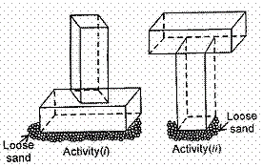  If p $​_{1}$ and p $​_{2}$ be the pressure exerted by the set - up in both the activities respectively, then the observation made by her is  a) P$​_{1}$ > P $​_{2}$  b) Data is insufficient  c) P$​_{1}$ < P $​_{2}$  d) P$​_{1}$ = P $​_{2}$ | [1]
19 | In the activity shown below, more impression will be made by the cuboid in the sand in case of image  a) both activities (i) and (ii)  b) neither in activity (i) nor in activity (ii)  c) activity (ii) only  d) activity (i) only | [1]
 | Section D
20 | Match the following columns with the correct response. 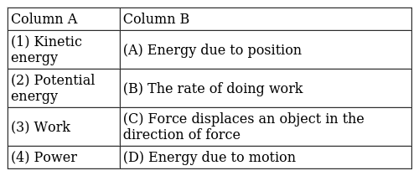  a) 1 - B, 2 - D, 3 - A, 4 - C  b) 1 - C, 2 - B, 3 - D, 4 - A  c) 1 - D, 2 - A, 3 - C, 4 - B  d) 1 - A, 2 - C, 3 - B, 4 - D | [1]
21 | Match the following with correct response.   a) 1 - A, 2 - C, 3 - B, 4 - D  b) 1 - B, 2 - D, 3 - A, 4 - C  c) 1 - D, 2 - A, 3 - C, 4 - B  d) 1 - C, 2 - B, 3 - D, 4 - A | [1]
22 | Match the following with correct response. 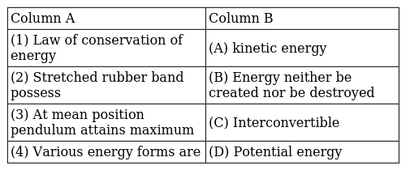  a) 1 - D, 2 - A, 3 - C, 4 - B  b) 1 - A, 2 - C, 3 - B, 4 - D  c) 1 - C, 2 - B, 3 - D, 4 - A  d) 1 - B, 2 - D, 3 - A, 4 - C | [1]
23 | Match the following with correct response. 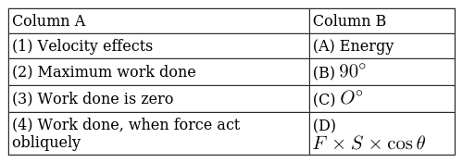  a) 1 - D, 2 - A, 3 - C, 4 - B  b) 1 - A, 2 - C, 3 - B, 4 - D  c) 1 - B, 2 - D, 3 - A, 4 - C  d) 1 - C, 2 - B, 3 - D, 4 - A | [1]
24 | Match the following with correct response. 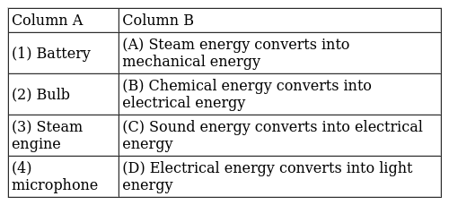  a) 1 - D, 2 - A, 3 - C, 4 - B  b) 1 - C, 2 - B, 3 - D, 4 - A  c) 1 - B, 2 - D, 3 - A, 4 - C  d) 1 - A, 2 - C, 3 - B, 4 - D | [1]
25 | Match the following with correct response. 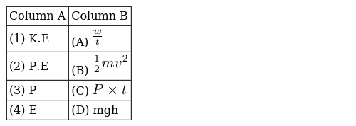  a) 1 - D, 2 - A, 3 - C, 4 - B  b) 1 - B, 2 - D, 3 - A, 4 - C  c) 1 - A, 2 - C, 3 - B, 4 - D  d) 1 - C, 2 - B, 3 - D, 4 - A | [1]
26 | Match the following with correct response. 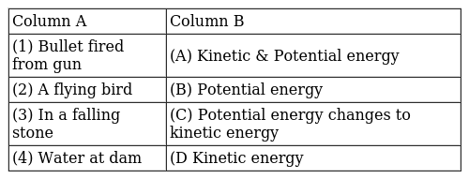  a) 1 - B, 2 - D, 3 - A, 4 - C  b) 1 - C, 2 - B, 3 - D, 4 - A  c) 1 - A, 2 - C, 3 - B, 4 - D  d) 1 - D, 2 - A, 3 - C, 4 - B | [1]
27 | Match the following with the correct response. 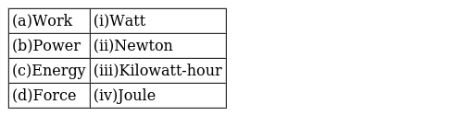  a) (a) - (i), (b) - (iii), (c) - (ii), (d) - (iv)  b) (a) - (iv), (b) - (i), (c) - (iii), (d) - (ii)  c) (a) - (ii), (b) - (iv), (c) - (i), (d) - (iii)  d) (a) - (iii), (b) - (ii), (c) - (iv), (d) - (i) | [1]
28 | Match the following with correct response. 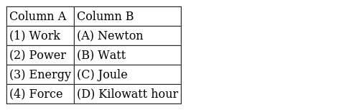  a) 1 - A, 2 - C, 3 - B, 4 - D  b) 1 - C, 2 - B, 3 - D, 4 - A  c) 1 - D, 2 - A, 3 - C, 4 - B  d) 1 - B, 2 - D, 3 - A, 4 - C | [1]
29 | Match the following with the correct response. 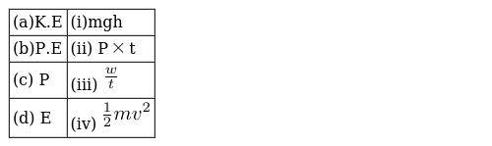  a) (a) - (ii), (b) - (iv), (c) - (i), (d) - (iii)  b) (a) - (iii), (b) - (ii), (c) - (iv), (d) - (i)  c) (a) - (i), (b) - (iii), (c) - (ii), (d) - (iv)  d) (a) - (iv), (b) - (i), (c) - (iii), (d) - (ii) | [1]
30 | Match the following with the correct response. 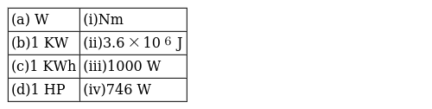  a) (a) - (iii), (b) - (ii), (c) - (iv), (d) - (i)  b) (a) - (iv), (b) - (i), (c) - (iii), (d) - (ii)  c) (a) - (i), (b) - (iii), (c) - (ii), (d) - (iv)  d) (a) - (ii), (b) - (iv), (c) - (i), (d) - (iii) | [1]
31 | Match the following with correct response.(1) Nm is also called (2) Free fall (3) A donkey is working with a load on its back (4) An engine is pulling train (A) Potential energy is equal to kinetic energy (B) Work done (C) No work done (D) Erg  a) 1 - B, 2 - D, 3 - A, 4 - C  b) 1 - A, 2 - C, 3 - B, 4 - D  c) 1 - C, 2 - B, 3 - D, 4 - A  d) 1 - D, 2 - A, 3 - C, 4 - B | [1]
32 | Match the following with the correct response. 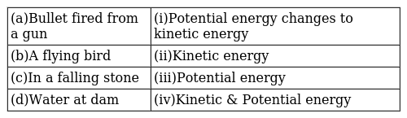  a) (a) - (ii), (b) - (iv), (c) - (i), (d) - (iii)  b) (a) - (iv), (b) - (i), (c) - (iii), (d) - (ii)  c) (a) - (i), (b) - (iii), (c) - (ii), (d) - (iv)  d) (a) - (iii), (b) - (ii), (c) - (iv), (d) - (i) | [1]
33 | Match the following with correct response. 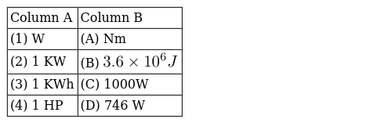  a) 1 - C, 2 - B, 3 - D, 4 - A  b) 1 - D, 2 - A, 3 - C, 4 - B  c) 1 - A, 2 - C, 3 - B, 4 - D  d) 1 - B, 2 - D, 3 - A, 4 - C | [1]
34 | Match the following with correct response.(1) Law of conservation of energy (2) Stretched rubber band possess (3) At mean position pendulum attains maximum (4) Various energy forms are (A) Inter convertible (B) Potential energy (C) Energy neither be created nor be destroyed (D) kinetic energy  a) 1 - B, 2 - D, 3 - A, 4 - C  b) 1 - A, 2 - C, 3 - B, 4 - D  c) 1 - D, 2 - A, 3 - C, 4 - B  d) 1 - C, 2 - B, 3 - D, 4 - A | [1]
35 | Match the following with the correct response. 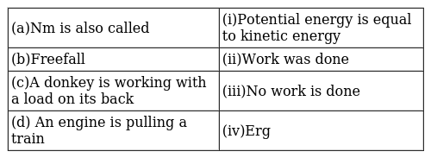  a) (a) - (iii), (b) - (ii), (c) - (iv), (d) - (i)  b) (a) - (iv), (b) - (i), (c) - (iii), (d) - (ii)  c) 1 - A, 2 - C, 3 - B, 4 - D  d) (a) - (ii), (b) - (iv), (c) - (i), (d) - (iii) | [1]
36 | Match the following with the correct response. 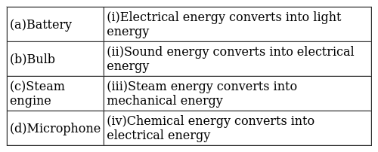  a) (a) - (i), (b) - (iii), (c) - (ii), (d) - (iv)  b) (a) - (ii), (b) - (iv), (c) - (i), (d) - (iii)  c) (a) - (iv), (b) - (i), (c) - (iii), (d) - (ii)  d) (a) - (iii), (b) - (ii), (c) - (iv), (d) - (i) | [1]
 | Section E
37 | Statement A: Speed of a gas molecule decreases with increase in temperature.Statement B: P. E of the body decreases as it falls towards the surface of the Earth. Which of the two statements is true?  a) statement B  b) both statement A and B  c) statement A and B are false  d) statement A | [1]
38 | Statement A: Any physical or mental activity is termed as work done in physics.Statement B: Work is said to be +ve work done when the body is displaced in the direction of applied force. Which of the two statements is true?  a) Statement A  b) neither A nor B  c) Statement B  d) Statement A and B | [1]
39 | Statement A: Mechanical energy of a system is always conserved.Statement B: The total energy of the system is always conserved. Which of the two statements is true?  a) statement A  b) statement A and B false  c) both statement A and B  d) statement B | [1]
40 | Statement A: If two bodies have the same K. E, then their momentum will also be equalStatement B: Work done by the centripetal force is always greater than zero. Which of the following statement is true?  a) statement B is true, A is false  b) both the statement A and B are true  c) neither statement A nor statement B is true.  d) statement A is true, B is false | [1]
41 | Statement A: Work is said to be done when a camel is carrying a load on its back.Statement B: Work is said to be done when a sailboat is moving due to wind energy. Which of the above statement is true?  a) neither A nor B  b) Statement A  c) Statement A and B  d) Statement B | [1]
42 | Statement A: An aeroplane flying at an altitude possesses only K. E.Statement B: An aeroplane flying at an altitude possesses both K. E and P. E. Which of the two statement is true?  a) statement A  b) neither Anor B  c) both Aand B  d) statement B | [1]
 | Section F
43 | Read the passage and answer any four questions: A speeding car, a rolling stone, a flying aircraft, flowing water, blowing wind, a running athlete, etc. possess kinetic energy. In short, kinetic energy is the energy possessed by an object due to its motion. The kinetic energy of an object increases with its speed. The kinetic energy of a body moving with a certain velocity is equal to the work done on it to make it acquire that velocity. Kinetic energy possessed by an object of mass, m and moving with a uniform velocity, v is $\frac{1}{2}$ mv $​^{2}$ . The work done is equal to the change in the kinetic energy of an object. 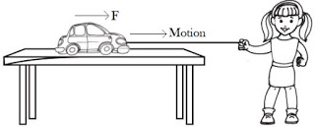  - If the speed of a car becomes 2 times, its kinetic energy becomes  - 4 times  - 8 times  - 16 times  - 12 times  - Work is done by friction  - increases the kinetic energy of the body  - decreases the kinetic energy of the body  - increases the potential energy of the body  - decreases the potential energy of the body.  - Choose the correct option among the following  - (I) and (III)  - (I) and (IV)  - Only (II)  - (II) and (IV)  - If the object is starting from its stationary position, that is, u = 0, then work is equal to  - $\frac{1}{2}$ mv  - 2mv  - 3mv  - $\frac{1}{4}$ mv  - An object of mass 15 kg is moving with a uniform velocity of 4ms$​^{−1}$ . What is the kinetic energy possessed by the object?  - 230J  - 130J  - 120J  - 240J  - A flying coconut posses:  - kinetic energy  - potential energy  - both (a) and (b)  - none of these | [4]
44 | Read the passage and answer any four questions: When an object throws upward the energy gets stored due to the work done on the object. The energy transferred to an object is stored as potential energy if it is not used to cause a change in the velocity or speed of the object. when you stretch a rubber band. The energy transferred to the band is its potential energy. An object increases its energy when raised through a height. This is because work is done on it against gravity while it is being raised. The energy present in such an object is the gravitational potential energy. The gravitational potential energy of an object at a point above the ground is defined as the work done in raising it from the ground to that point against gravity. 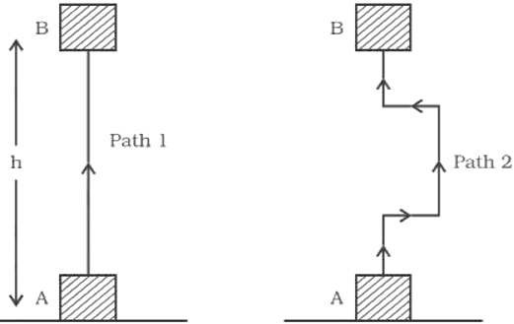  - The potential energy of a body depends on its:  - position  - configuration  - position and configuration  - mass and velocity  - Which of the following energy change involves frictional force?  - kinetic energy to heat energy  - potential energy to sound energy  - chemical energy to heat energy  - chemical energy to light energy  - When a coil spring is compressed, the work is done in the spring. The elastic potential energy  - increases  - decreases  - disappears  - remains unchanged  - Water stored in a dam possesses  - no energy  - electrical energy  - kinetic energy  - potential energy  - A body is falling from a height h. After it has fallen a height$\frac{1}{2}$ h, it will possess  - only potential energy  - only kinetic energy  - half potential and half kinetic energy  - more kinetic and less potential energy | [4]
45 | Read the passage and answer any four question A more powerful vehicle would complete a journey in a shorter time than a less powerful one.The speed with which these vehicles change the energy or do work is a basis for their time to complete the journey.Power measures the speed of work done, that is, how fast or slow work is done.The power of an agent may vary with time. This means that the agent may be doing work at different rates at different intervals of time.If this machine is used continuously for one hour, it will consume 1 kW h of energy. Thus, 1 kW h is the energy used in one hour at the rate of 1000 J s $​^{​​​​​​−1}$ ​​​​s - 1.The energy used in households, industries, and commercial establishments is usually expressed in kilowatt - hour.  - SI unit of power is  - watt  - joule  - newton  - meter  - Power is defined as  - the rate of doing work  - the rate of transfer of energy  - both (a) and (b)  - neither (a) nor (b)  - 1 watt is equal to work at the rate of(I) 1 joule per second (II) 1 joule per hour (III) 1 joule per minute (IV) 4 joule per hour Choose the correct option among the following  - Only (I)  - (I) and (IV)  - (II) and (III)  - (II) and (IV)  - An electric bulb of 60 W is used for 6 h per day. Calculate the ‘units’ of energy consumed in one day by the bulb.  - 0.76 unit  - 0.36 unit  - 0.98 unit  - 0.76 unit  - Which of the following statement are incorrect(I)A bird sitting on a tree possesses potential energy only. (II) A stationary object may have energy. (III) A flying bird has kinetic energy only. (IV) An aeroplane running on the runway possesses kinetic and potential energy both.  - III and IV  - I and III  - II and III  - II and IV | [4]
46 | Read the passage and answer any four question Life is impossible without energy.The Sun is the biggest natural source of energy for us.An object that possesses energy can exert a force on another object. When this happens, energy is transferred from the former to the latter. The second object may move as it receives energy and therefore does some work. Thus, the first object had the capacity to do work. This implies that any object that possesses energy can do work. The energy possessed by an object is thus measured in terms of its capacity of doing work. According to the law of conservation of energy, the total energy before and after the transformation remains the same.  - One joule work is said to be done when(I) a force of 1 N displaces a body by 1 cm (II) a force of 1 N displaces a body by 1 m (III) a force of 1 dyne displaces a body by 1 m (IV) a force of 1 dyne displaces a body by 1 cm. Choose the correct option among the following:  - (I) and (III)  - (I) and (IV)  - (II) and (III)  - Only (II)  - Energy can neither be_________nor be ________it can only be transformed from one form to another.  - created, destroyed  - formed, reversed  - invented, discovered  - none of these  - 1KJ us equal to  - 1000J  - 200J  - 3000J  - 500J  - The head of a nail hammered into the wooden plank becomes hot. This is because of:  - conversion of K. E into heat energy.  - conversion of P. E into heat energy.  - conversion of chemical energy into heat energy.  - conversion of mechanical energy into heat energy.  - Whenever energy gets transformed, the total energy  - became zero  - remain unchanged  - changes  - none of these | [4]
47 | Read the passage and answer any four questions: All living beings need food. Living beings have to perform several basic activities to survive. The energy for these processes comes from food. All such activities require energy. In day - to - day life, we consider any useful physical or mental labour as work. Activities like playing in a field, talking with friends, humming a tune, watching a movie, attending a function are sometimes not considered to be work. Push a pebble lying on a surface. The pebble moves through a distance. You exerted a force on the pebble and the pebble got displaced. In this situation, work is done. Thus, work done by a force acting on an object is equal to the magnitude of the force multiplied by the distance moved in the direction of the force. 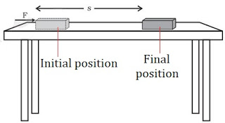  - A force of 5 N is acting on an object. The object is displaced through 2 m in the direction of the force, then work done is  - 10J  - 29J  - 30J  - 40J  - In case of negative work, the angle between the force and displacement is  - 0°  - 45°  - 90°  - 180°  - The work done on an object does not depend upon the  - displacement  - force applied  - angle between force and displacement  - initial velocity of the object  - The condition required to work to be done  - a force should act on object  - object must be displaced  - force should act perpendicular to the object  - the object should not move  - Choose the correct option among the following  - (I) and (III)  - (I) and (II)  - (II) and (III)  - Only (IV)  - Amount of Work done if force is perpendicular to the displacement is  - 90 percent  - 20 percent  - zero work done  - 100 percent | [4]
48 | Work is closely related to energy . The work - energy principle states that an increase in the kinetic energy of a rigid body is caused by an equal amount of positive work done on the body by the resultant force acting on that body.  - Define potential energy.  - Give an example where potential energy is acquired by a body due to change in its shape. 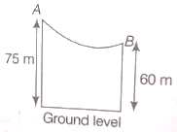  - A skier of mass 50 kg stands at A, at the top of a ski jump. He takes off from A for his jump to B. Calculate the change in his gravitational potential energy between A and B. | [3]
49 | Potential energy is storedenergythat depends upon the relative position of various parts of a system. Spring has more potential energy when it is compressed or stretched. A steel ball has more potential energy raised above the ground than it has after falling toEarth. 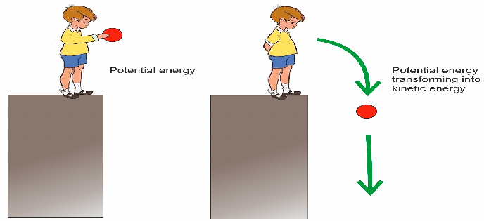  If a body falls from a height bounces from the ground and again goes upwards with loss of a part of its energy.  - How will its potential energy change?  - What are various energy conversions taking place?  - What will be its ultimate energy? | [3]
50 | In physics, work is the energy transferred to or from an object via the application of force along with a displacement. In its simplest form, it is often represented as the product of force and displacement. A force is said to do positive work if (when applied) it has a component in the direction of the displacement of the point of application. A force does negative work if it has a component opposite to the direction of the displacement at the point of application of the force. 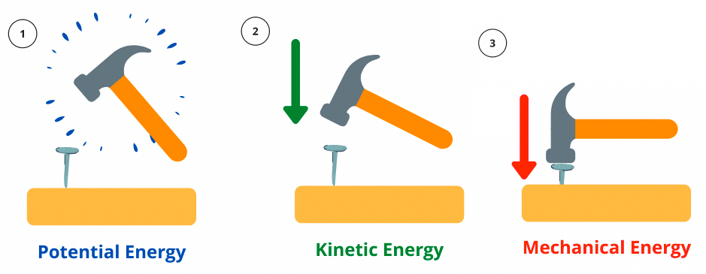  - State the law of conservation of energy.  - Define mechanical energy.  - Calculate the energy in kWh consumed in 5 hours by four devices of power 600 W each. | [3]
51 | A vehicle of 1 tonne travelling by a speed of 60 ms$​^{−1}$ notices a cow on the road 9m ahead applies brakes. It stops just in front of the cow.  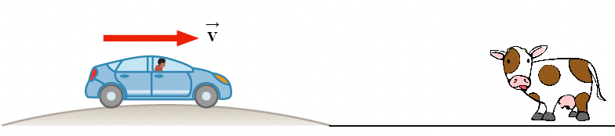  - Find out the KE of the vehicle before applying brakes.  - Calculate the retarding force provided by the brakes.  - How much time did it take to stop after the brakes were applied?  - What is the work done by the braking force? | [3]
52 | Work is the energy applied to an object as it moves some distance. The amount of work done is directly proportional to the magnitude of force applied, as well as the displacement of the object. In some cases, there may be an angle between the direction of displacement and the force vector. A body of mass 5 Kg is lifted vertically at a height of 12m. 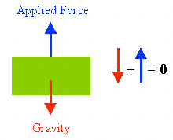  Calculate  - The force applied  - Work Done in lifting the body  - What happens to the work performed? | [3]
53 | Electrical energy is energy derived as a result of the movement of electrically charged particles. When used loosely, electrical energy refers to the energy that has been converted from electric potential energy. 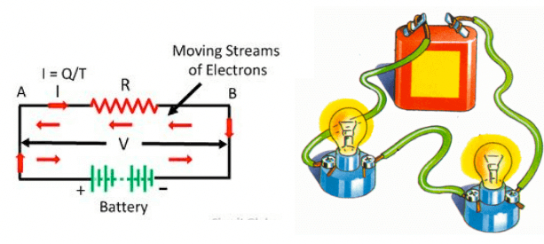  - When 1 Joule of work is said to be done?  - An electric oven is rated 5000 W. How many units of electrical energy does it use in 2 hours?  - When a carpet is beaten with a stick, dust comes out of it. Explain. | [3]
54 | Potential energy is storedenergythat depends upon the relative position of various parts of a system. Spring has more potential energy when it is compressed or stretched. A steel ball has more potential energy raised above the ground than it has after falling toEarth.   A mass of 10 kg is dropped from a height of 50 cm. Find its  - potential energy just before dropping.  - kinetic energy just on touching the ground.  - velocity with which it hits the ground. (take, q = 10 ms$​^{−2}$ ) | [3]
55 | Work is done whenever a force moves something over a distance . You can calculate the energy transferred, or work done, by multiplying the force by the distance moved in the direction of the force. Energy transferred = work done = force x distance moved in the direction of the force. 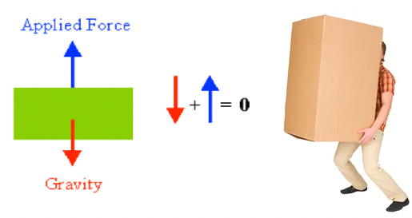  Four men lift a 250 kg box to a height of 1 m and hold it without raising or lowering it.  - How much work is done by the men in lifting the box?  - How much work do they do in just holding it?  - Why do they get tired while holding it? (g = 10 ms$​^{−2}$ ) | [3]
56 | In physics, potential energy is the energy held by an object because of its position relative to other objects, stresses within itself, its electric charge, or other factors. The kinetic energy of an object is the energy that it possesses due to its motion. It is defined as the work needed to accelerate a body of a given mass from rest to its stated velocity. A car is moving on a levelled road and gets its velocity doubled. 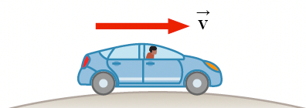  In this process,  - How would thepotential energy of the car change?  - Howwould the kinetic energy of the car change?  - How will its momentum change? Give reasons for your answer. | [3]
57 | A car of mass 900 kg is travelling at a steady speed of 30 m/s against a resistive force of 2000 N, as illustrated in figure. 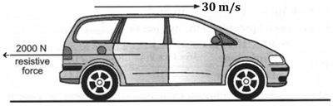  - Calculate the kinetic energy of the car.  - Calculate the energy used in 1.0 s against the resistive force.  - What is the minimum power what the car engine has to deliver to the wheels?  - What form of energy is in the fuel, used by the engine to drive the car? | [3]

